Home

Public AR Index()

{

Return View();

}

Public AR Index1()

{

Return RedirecttoAction(“Index”);

}

One folder in Views > Home > index.cshtml , index1.cshtml

Layout > It is used for common look and feel for all the views (Its a template)

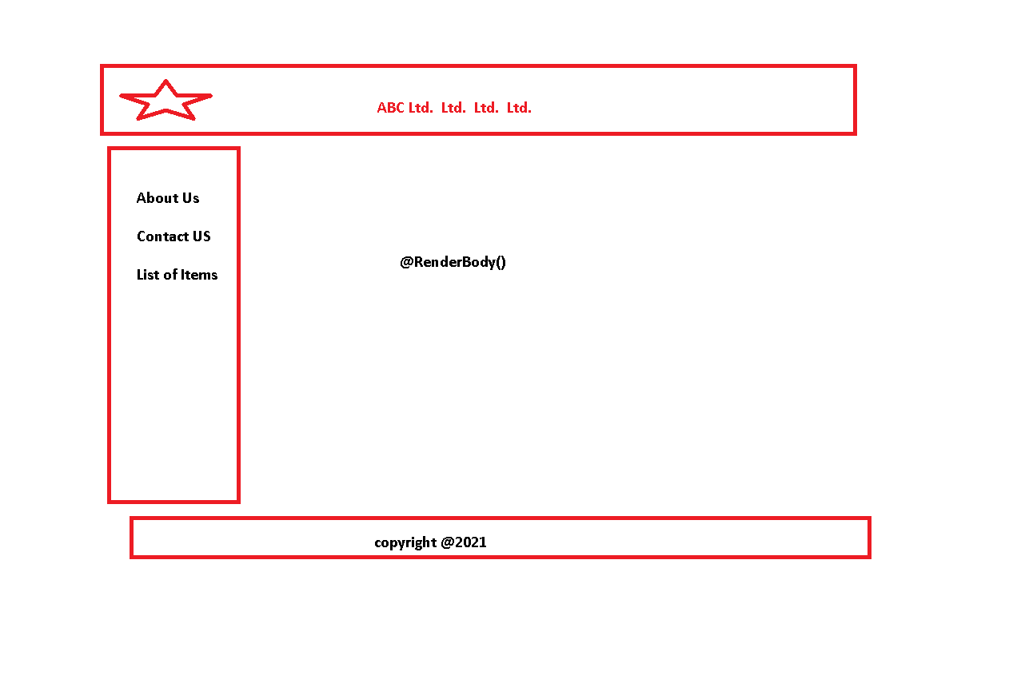

<!DOCTYPE html>

<html>

<head>

<meta name="viewport" content="width=device-width" />

<title></title>

</head>

<body>

<div>

<table style="width:100% ;height:80%;background-color:antiquewhite">

<tr>

<td>

<img src="~/Images/mslogo.jpg" height="100" width="100" /> </td>

<td>

<h2> ABC LTD. </h2>

</td>

</tr>

<tr>

<td>

<a href="~/Add/AddNumbers"> About Us </a>

<br />

<a href="~/Views/Add/AddNumbers.cshtml"> Contact Us </a>

<br />

<a href="~/Views/Add/AddNumbers.cshtml"> List of Employees </a>

</td>

<td>

@RenderBody()

</td>

</tr>

<tr>

<td colspan="2">

<footer style="align-content:center"> copyright@2021</footer>

</td>

</tr>

</table>

</div>

</body>

</html>

_ViewStart.cshtml

@{

//Layout = "~/Views/Shared/_Layout.cshtml";

Layout = "~/Views/Shared/_MyLayout.cshtml";

}